

Deccan Education Society’s

FERGUSSON COLLEGE(AUTONOMOUS), PUNE-4

Department of Computer science

A

Project Report

On

PRE-PLACEMENT ACTIVITY

By

1.Shivam Dandavate Roll No:226254

2.Vaibhav Narsinge Roll No:226259

3.Navjivan Thorat Roll No:226211

[2022-2023]

Deccan Education Society’s

FERGUSSON COLLEGE(AUTONOMOUS), PUNE-4

Department of Computer science

A

Project Report

On

PRE-PLACEMENT ACTIVITY

In partial fulfilment of the completion of F.Y.M. Sc (C.S)

Semester-I

Master Of Science

Computer Science

SUBMITTED BY

1.Shivam Dandavate Roll No:226254

2.Vaibhav Narsinge Roll No:226259

3.Navjivan Thorat Roll No:226211

Under the Guidance of

Professor Mr. Irfan Khatik

[2022-2023]

(CSC4106) Computer Science Project-I

CERTIFICATE

This is to certify’ that the project entitled **PRE-PLACEMENT ACTIVITY** Completed by

1. Shivam Laximikant Dandavate (226254)

2. Vaibhav Balu Narsinge (226259)

3. Navjivan Rajendra Thorat (226211)

In partial fulfillment of the requirement of the completion of M.Sc.(C.S). Semester-I has been carried out by team under my guidance satisfactorily during the academics year 2022-2023.

Place: Pune

Date: / /2022

Mr. Irfan Khatik Dr. Kavita A. Khobragade

Project Guide Head, Computer Science Department

Internal Examiner: External Examiner:

**ACKNOWLEDGEMENT**

I take this opportunity to express my gratitude to our guide, Professor Mr. Khatik Sir, as well as our Head of department Dr. Kavita A. Khobragade who gave us valuable suggestions and noble guidance at all stages of this project study.

I also express our sincere thanks to our Professors for giving us

consistent encouragement, support and valuable guidance throughout the

course of the project without their stable guidance this project would not have

been achieved. I am also thankful to the authority of “FERGUSSON COLLEGE” for their support in our project.

Finally, we would like to thank all those friends who are involved directly and

indirectly in completion of our project.

1.Shivam Dandavate Roll No:226254

2.Vaibhav Narsinge Roll No:226259

3.Navjivan Thorat Roll No:226211

**Index**

|  |  |  |  |
| --- | --- | --- | --- |
| Sr. No |  | Topic | Page Number |
| 1. |  | Introduction | 6 |
|  | 1.1 | Existing System and Problem Definition | 7 |
|  | 1.2 | Need for the New system | 7 |
|  | 1.3 | Overview of the Project | 7 |
| 2. |  | Analysis | 8 |
|  | 2.1 | Feasibility Study | 8 |
|  | 2.2 | Hardware and Software Requirements | 10 |
| 3 |  | Design | 11 |
|  | 3.1 | Database Table Designing | 11 |
|  | 3.2 | UML DIAGRAM  User case diagram  Class Diagram  E-R Diagram | 13 |
|  | 3.3 | Input and Output Screens And Report | 17 |
| 4 |  | Testing | 21 |
|  | 4.1 | Importance of testing | 21 |
|  | 4.2 | Types of testing | 21 |
|  | 4.3 | Test cases | 22 |
| 5 |  | Drawbacks/Limitation | 24 |
| 6 |  | Conclusion | 24 |
| 7 |  | Future Enhancement | 25 |
| 8 |  | Reference and Bibliography | 26 |

**INTRODUCTION**

This project is aimed at developing an web application for the pre-placement activity organize by College. Pre-placement activities help student for placement of Company’s. It mostly focus on individual student performance and placements question’s. The system is a web application that can be accessed throughout the organization with proper login provided.

The pre-placement activity provides practice exams, exams and study material of different subjects to study for student. The key feature of this project is that it is a onetime registration. Our project provides the facility of maintaining the details of the students. In Admin login you can get all information about student such as how many exam a particular student has given and what marks it score.

This will also help in fast access procedures in pre-placement activity

The pre-placement activity is useful for student to see his performance, and try to improve over performance.

* 1. **EXISTING SYTSEM OR PROBLEM DEFINITION**

In our college, usually with the help of offline exam’s and pre-placement lectures the skills and assessment test of student are taken. This leads to more expensive and time consuming for college. To resolve offline pre-placement activity exam’s we decide to create our own platform for the pre-placement activity

* 1. **NEED FOR NEW SYSTEM**

The earlier system isn’t computerized. All transaction within system are done through pre-placement head by manually maintaining records. Student’s transcripts are difficult to manage and track. The management and every one in the departments that are concluding this job using placement makes the task more complicated and tedious most of the time. So, the most effective way is to computerizing of the present environment. In various colleges, teacher or pre-placement head have to manage student profile and documents of students of pre-placement activity.

* 1. **OVERVIEW OF THE PROJECT**

This project is to facilitate students in college. The student can access easily to this and data can be retrieved easily in no time. In the main page there are options for student and admin. For student there is new registration, login. A registered student to directly login using emailId and password. In student registration form, we can give personal details, email, phone no, Class. Admin can login using username and password that is directly given in system. In these system student can give practice test, test and get study material, view marks.

**ANALYSIS**

**2.1 FEASIBILITY STUDY**

Feasibility study is preliminary study undertaken to determine and document a project’s viability. The term feasibility study is also used to refer to the resulting document. These results of this study are used to make a decision whether to proceed with the project, or table it. If it indeed leads to a project being approved, it will – before the real work of the proceed project starts – be used to ascertain the likelihood of the project’s success. It is an analysis of possible alternative solutions to a problem and a recommendation on the best alternative.

**2.1.1 TECHNICAL FEASIBILITY**

This involves questions such as whether the technology needed for the system exists, how difficult it will be to build, and whether the firm has enough experience using that technology. The assessment is based on an outline design of system requirements I n terms of Input, Processes, Output, Fields, Programs, and Procedures. This can be qualified in terms of volumes of data, trends, frequency of updating in order to give an introduction to the technical system. The application is the fact that it has been developed on Windows platform and a high configuration of 1GB RAM on Intel Pentium dual core processor. This is technically feasible

**2.1.2 OPERATIONAL FEASIBILITY**

It is found out whether the current work practices and procedures support a new system. Also social factors i.e. how the organizational changes will affect the working lives of those affected by the system

**2.1.3 ECONOMIC FEASIBILITY**

Establishing the cost-effectiveness of the proposed system i.e. if the benefits do not outweigh the costs then it is not worth going ahead.

In the fast paced world today there is great need of online social networking

Facilities. Thus the benefits of this project in the current scenario make it economically feasible

**2.2 HARDWARE AND SOFTWARE REQUIRMENTS**

**HARDWARE REQUIRMENT:**

Minimum RAM : 4GB

Minimum Hard Disk – 128GB

Processor- Intel Pentium(1.50 GHz) or above

**SOFTWARE REQUIRMENT:**

Operating System : Windows 10 or above

Browser : Google chrome, I Explorer

Database : MY SQL

Performance : The turn-around time of the project will be medium

MY SQL = It is relational database management system. As a database it’s a software product whose primary function is to store and retrieve data as requested by other software applications, be it those on the same computer or those running on another computer across a network.

**DESIGN**

**3.1 Database Table Designing**

**Admin**

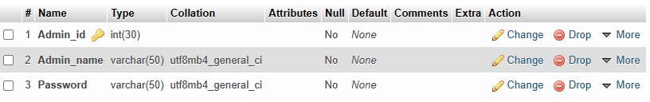

**Exam**

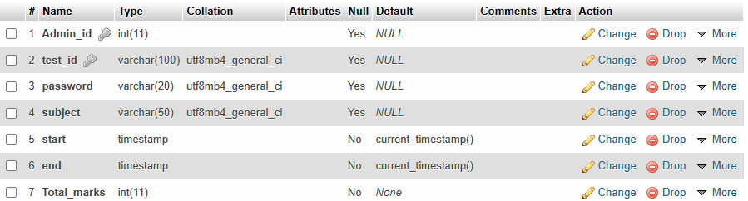

**Exam Question**

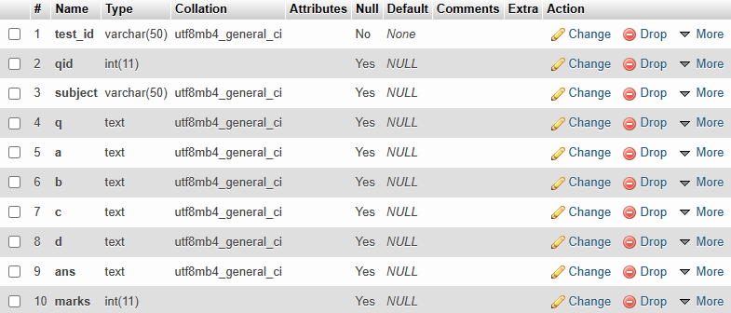

**Question**

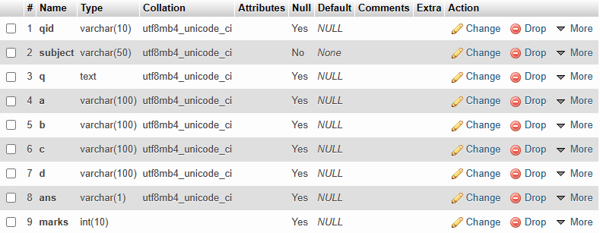

**Response**

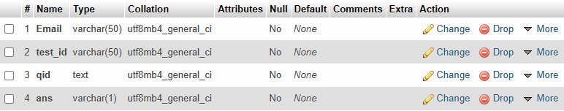

**Student**

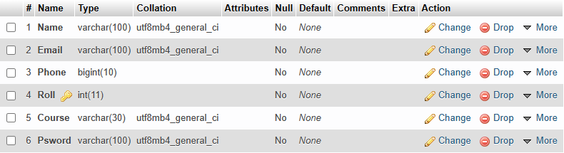

**Student test info**

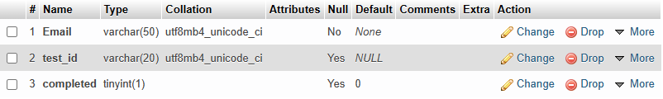

**3.2 UML DIAGRAM**

**USER CASE DIAGRAM**

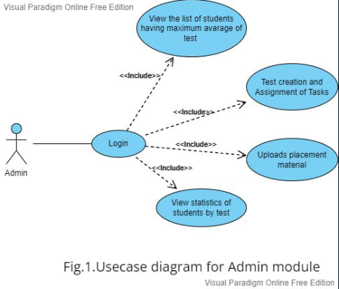

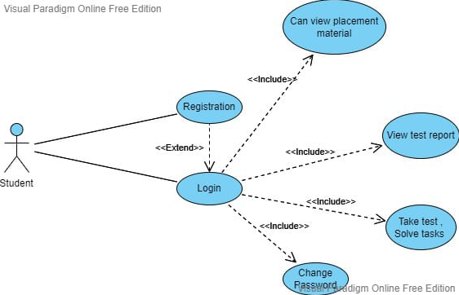

Fig.2 Use case diagram for Student module

**ENTITY RELATIONSHIP DIAGRAM**

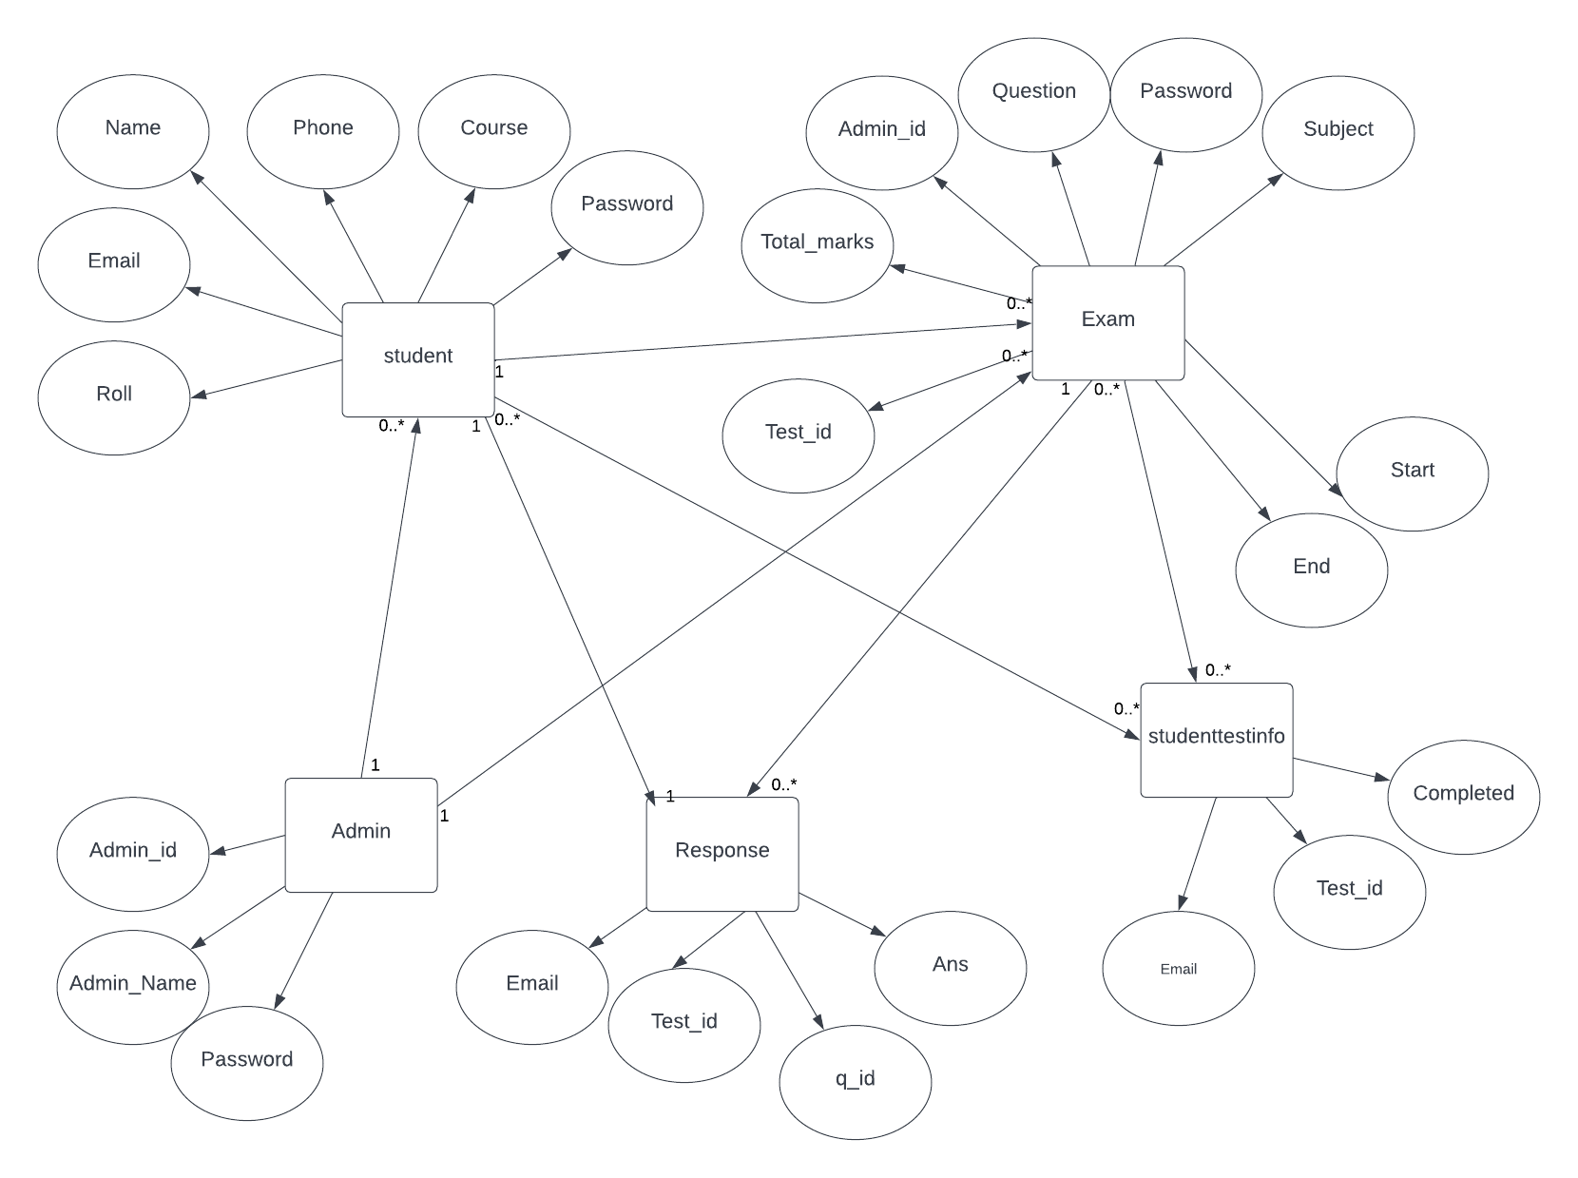

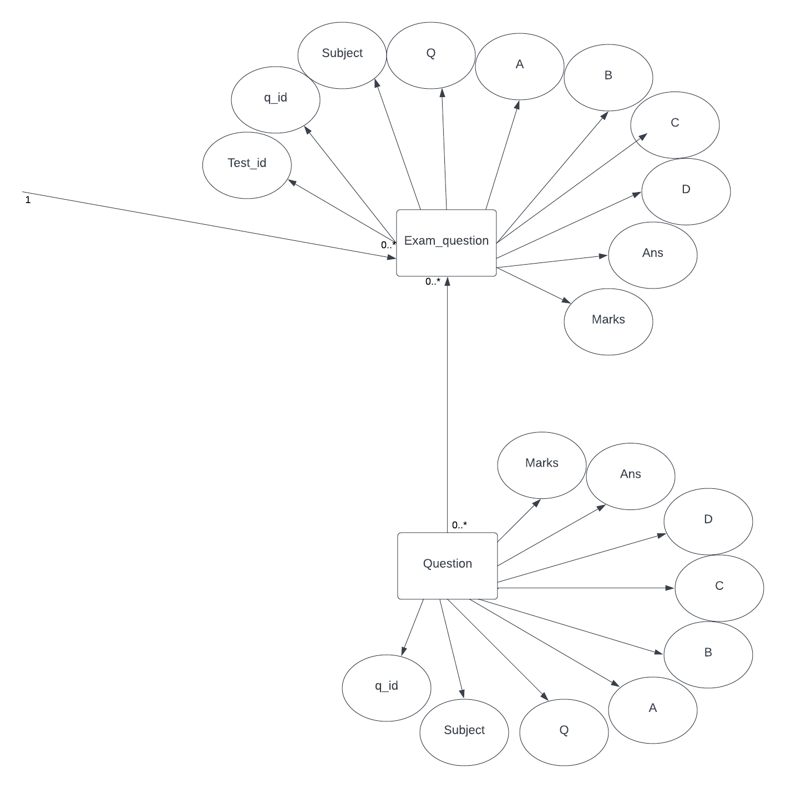

Fig 3. Entity Relationship diagram

**CLASS DIAGRAM**

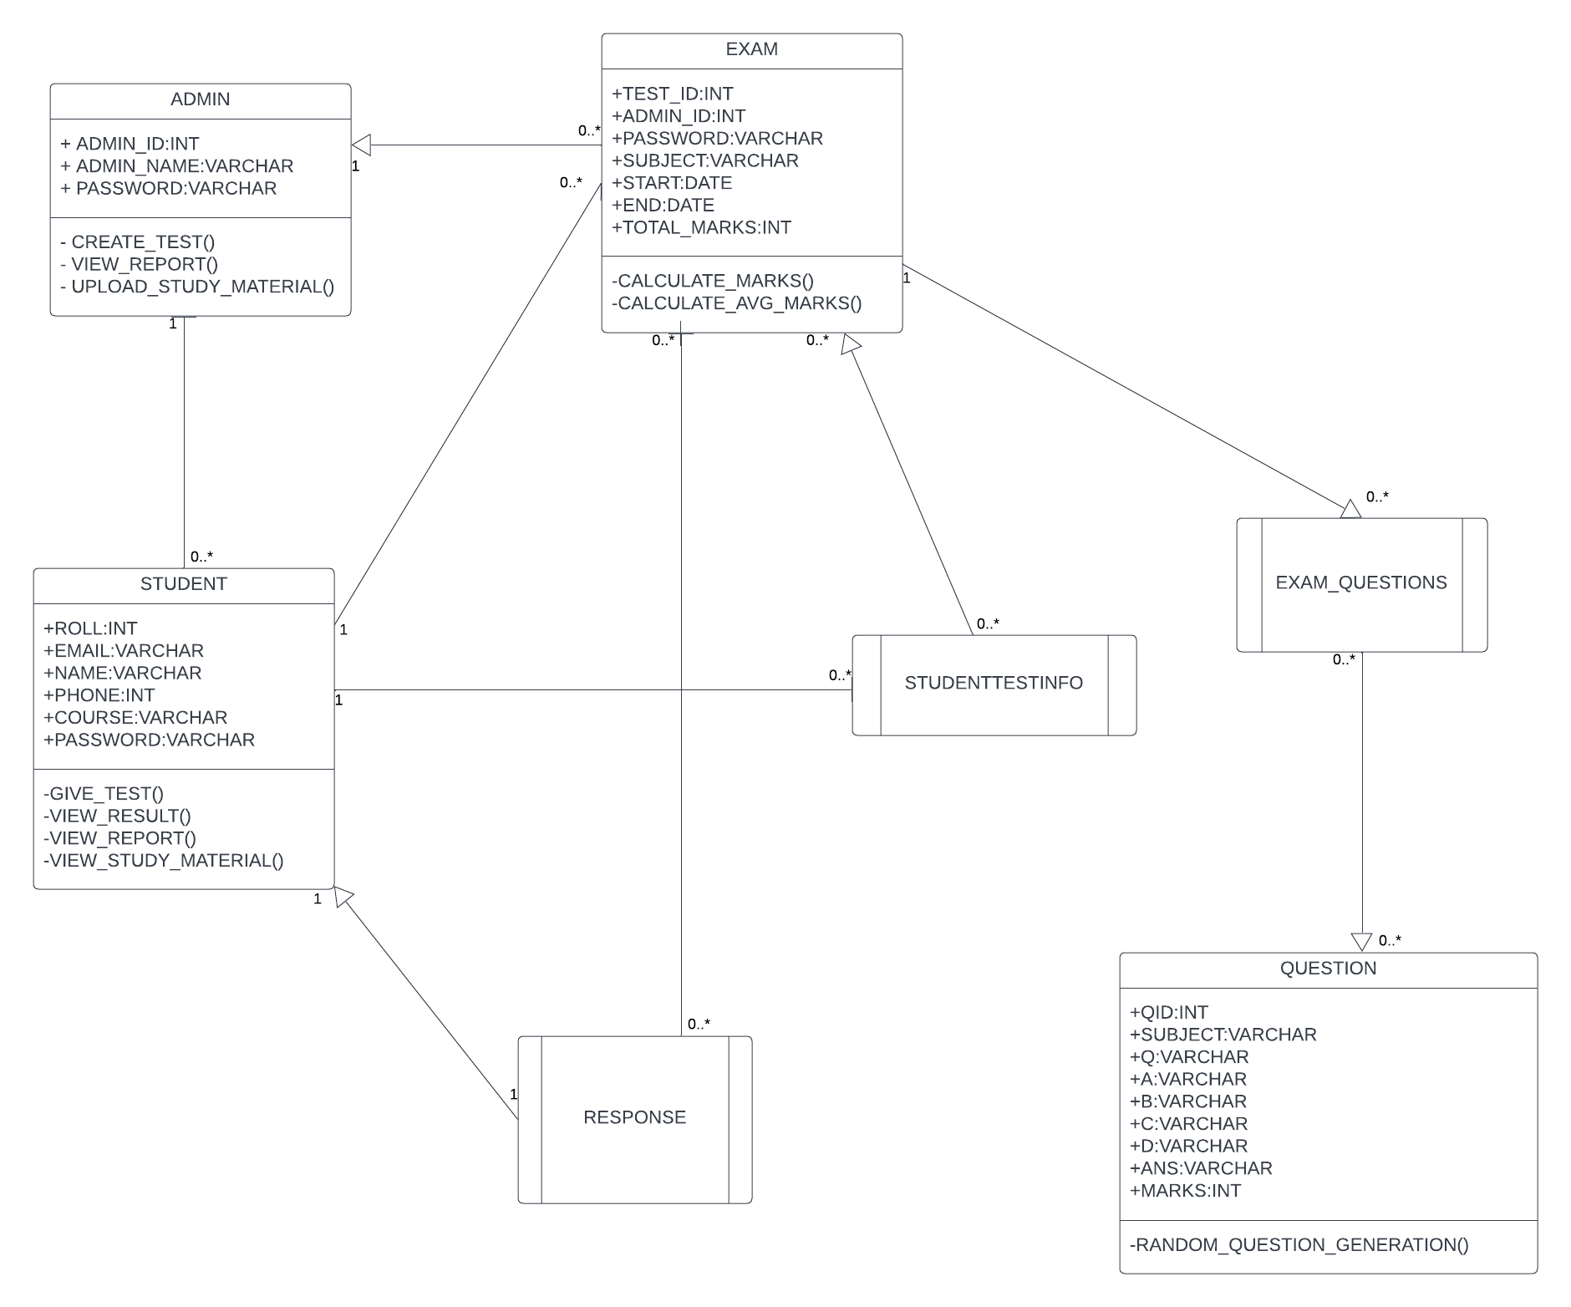

**3.3 INPUT AND OUTPUT SREENS**

**Home Screen:**

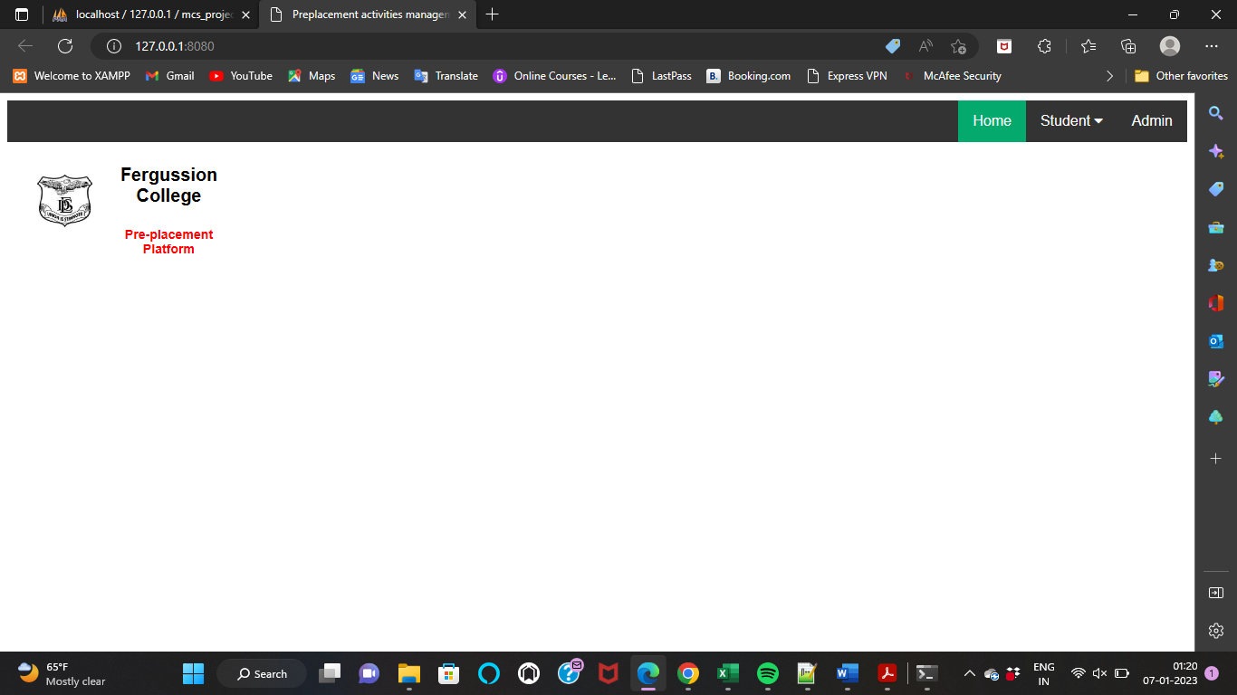**Student Registration:**

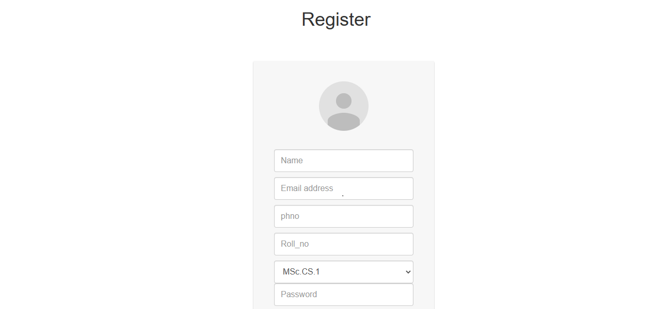



**Student login:**

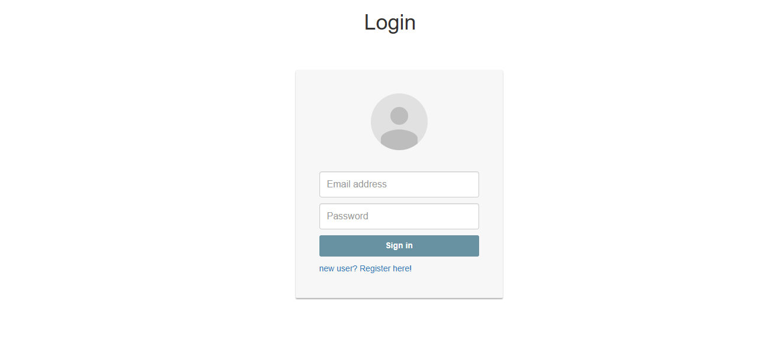

**Student dashboard:**

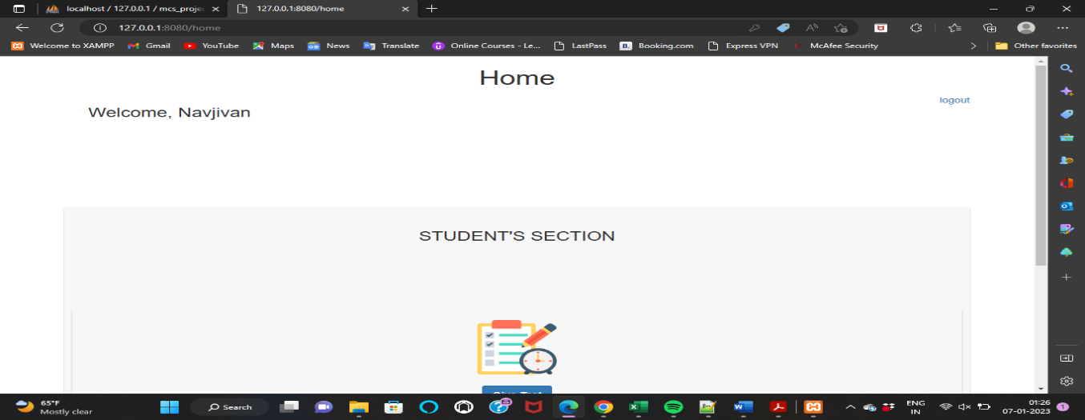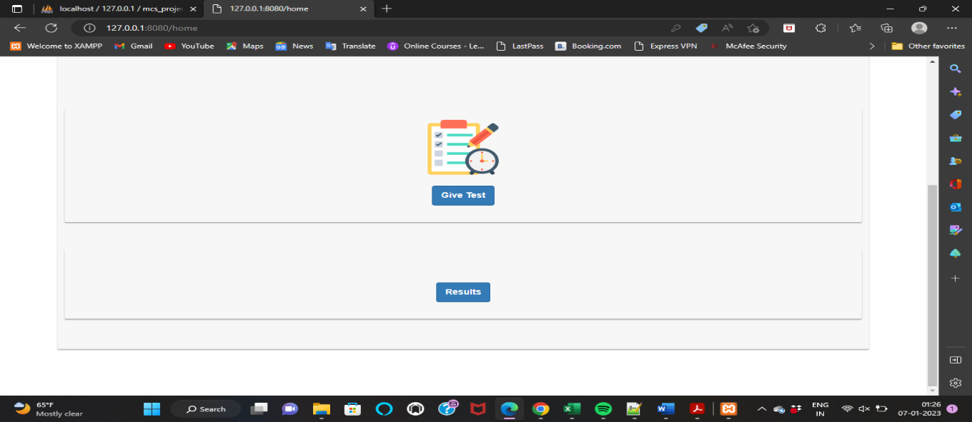

**Student Give test**

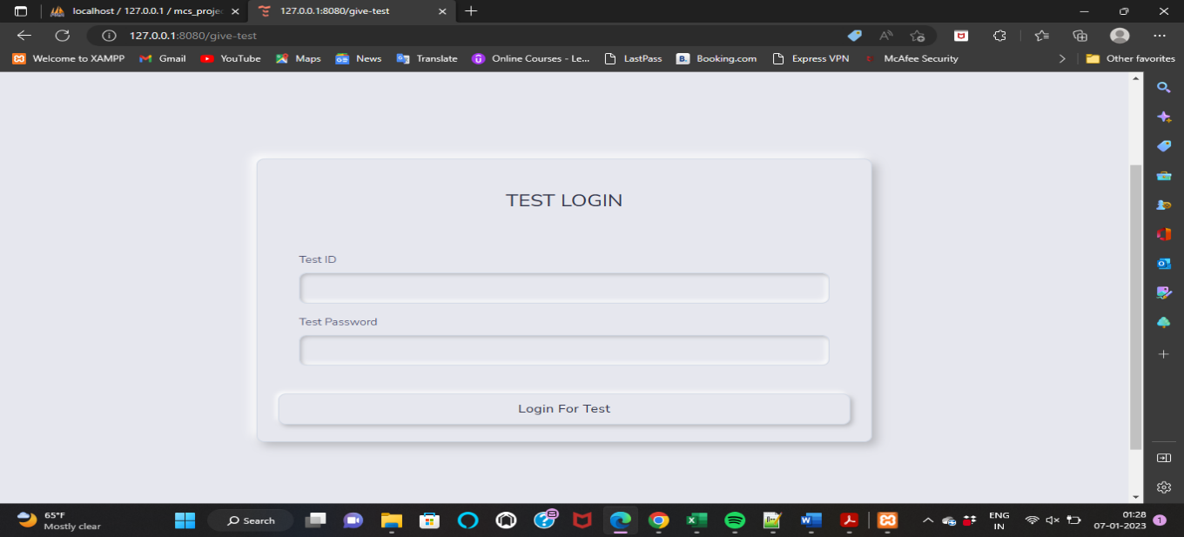

**Admin dashboard**

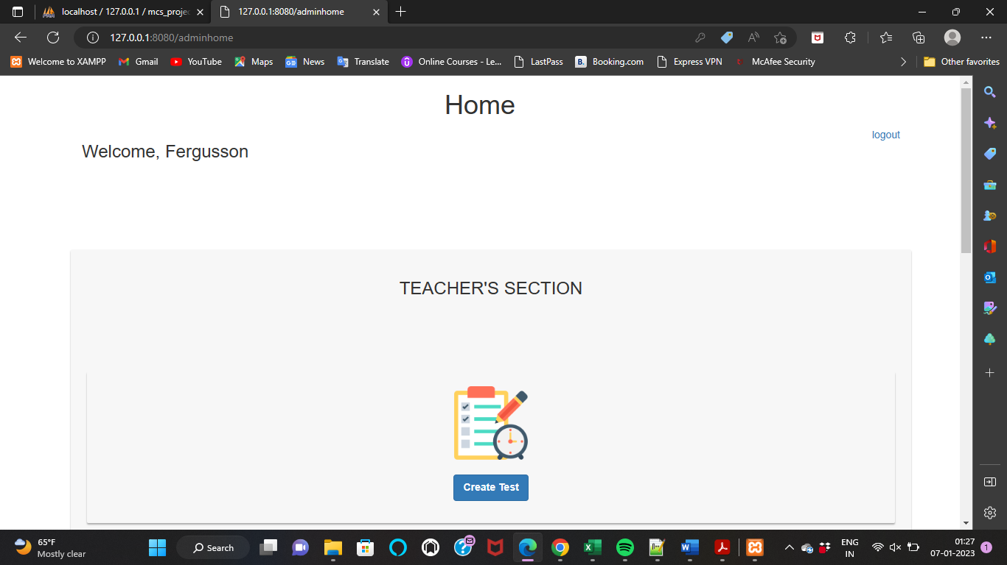

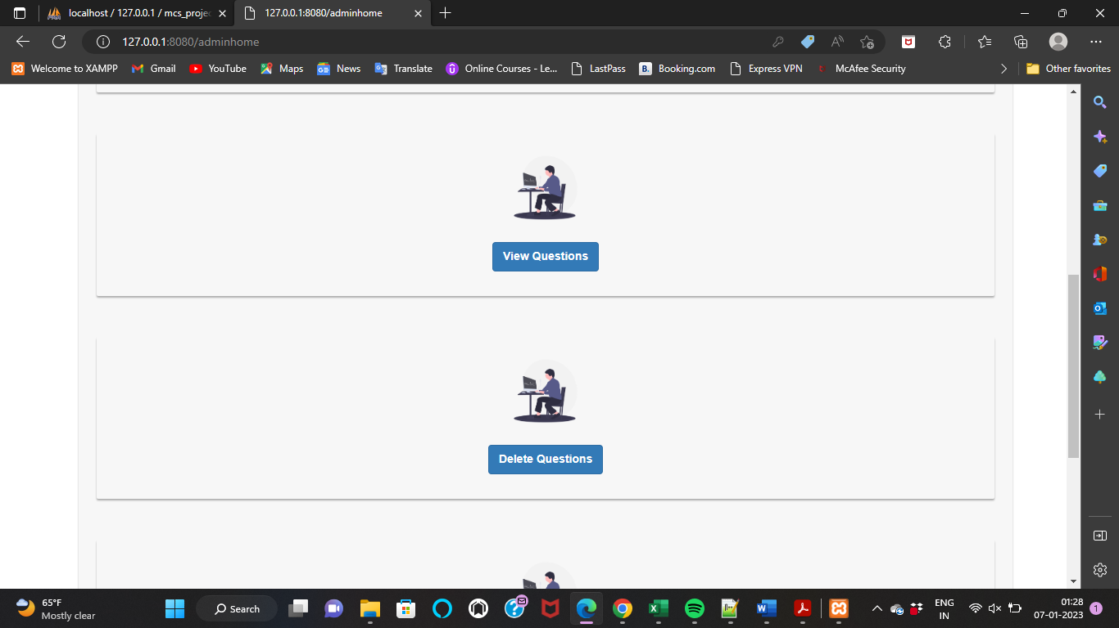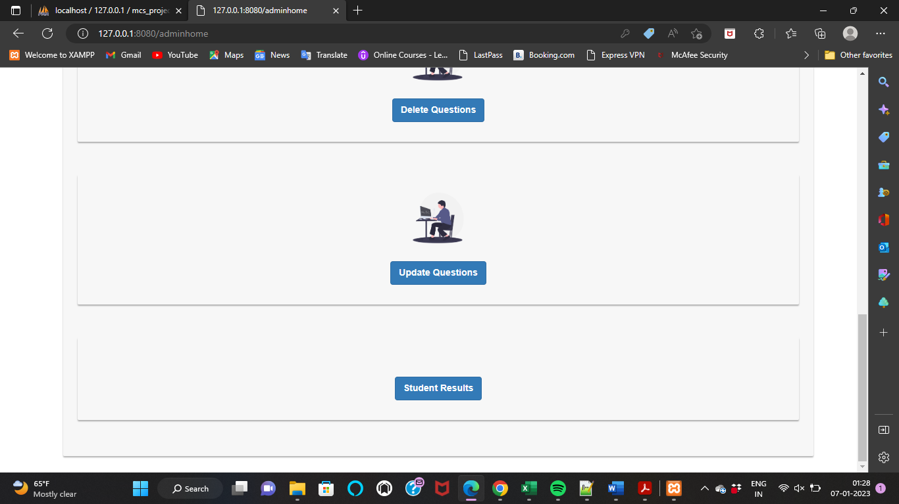

**Create test**

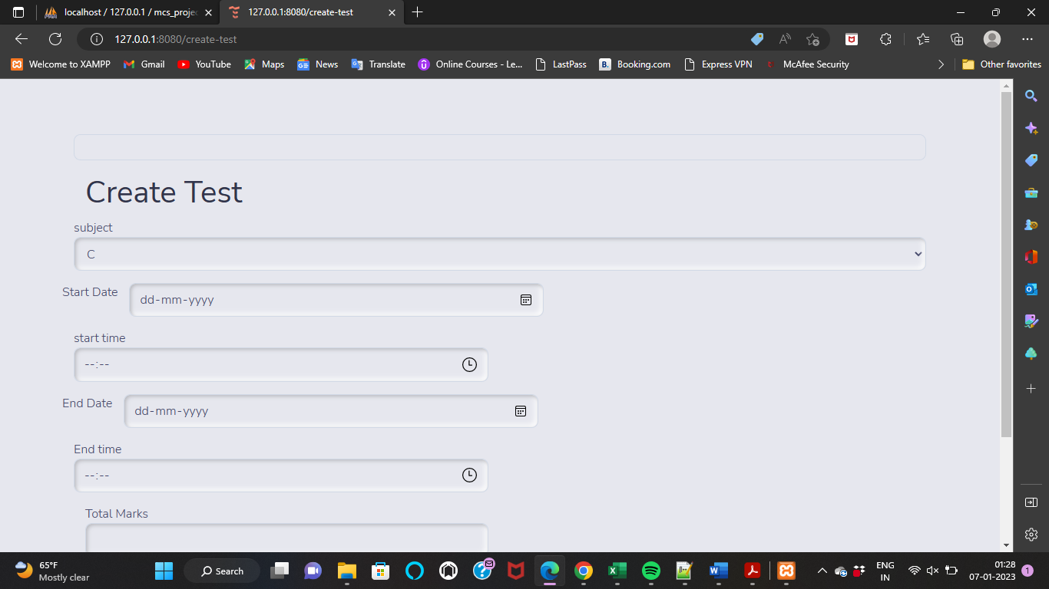

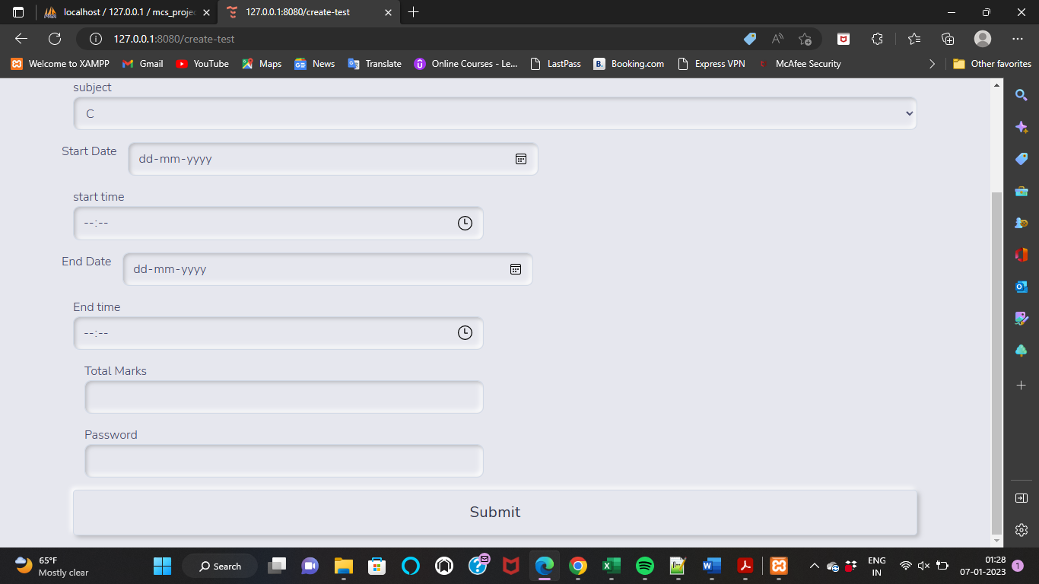

**Student Result:**

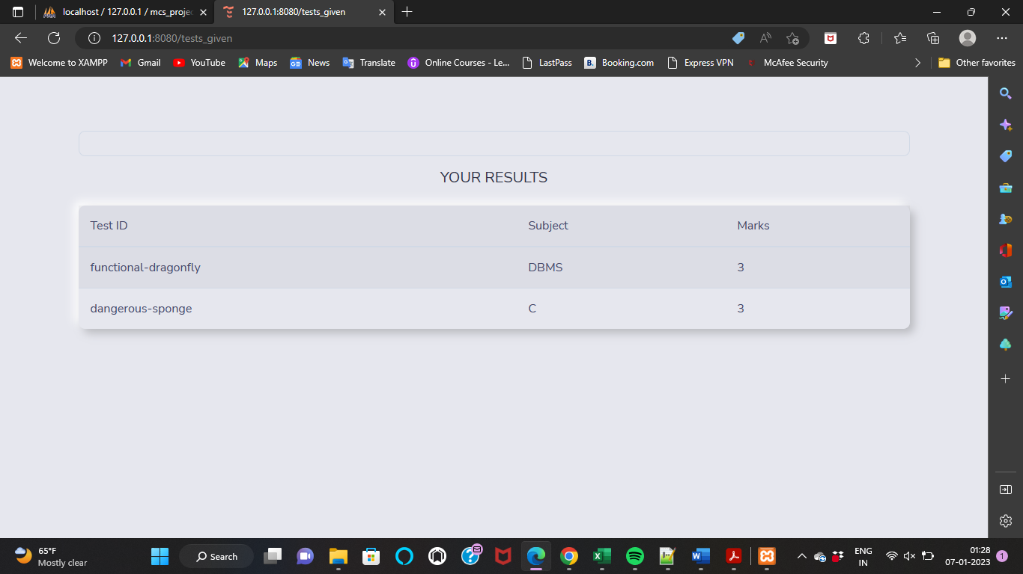

**TESTING**

**4.1 IMPORTANCE OF TESTING**

Testing is the stage of implementation, which is aimed at ensuring that the system works accurately and efficiently before live operation commences. The logical design and physical design is thoroughly and continually examined on paper to ensure that they will work when implemented.

Thus the system test in implementation was a confirmation that all is correct and an opportunity to show the users that the system works.

**4.2 TYPES OF TESTING**

Testing of the online classified system was performed in three stages which are follows –

* Unit Testing
* Integration Testing
* System Testing

**4.3 TEST CASE DESIGN**

|  |  |  |  |  |  |
| --- | --- | --- | --- | --- | --- |
| Page |  | Input Case | Output Case | Actual Result | Pass/  Fail |
| 1. | Register | 1]Empty Block of information  2]Wrong Phone no  3]Mismatched  password  4]All information correct | Requires all information popups  Invalid  Phone no  Authentication  Error  Open login page  With popup registration successfully | Require all information popup  Invalid  Phone no  Authentication  Error  Open login page  With popup registration successfully | Pass  Pass  Pass  Pass |
| 2. | Login | 1] ]Empty Block of information  2]Invalid email  3]invalid password  4]All information correct | Requires all  Information  Invalid email  Invalid password  Opens dashboard of student | Requires all  Information  Invalid email  Invalid password  Opens dashboard of student | Pass  Pass  Pass  Pass |
| 3. | Admin | 1]Empty Block of information  2]Invalid username  3]invalid password  4]All information correct | Requires all  Information  Invalid userid  Invalid password  Opens dashboard of admin | Requires all  Information  Invalid userid  Invalid password  Opens dashboard of admin | Pass  Pass  Pass  Pass |
| 4. | Create Test | 1]All information is correct  2]invalid information for any value | Test is created and get test id  Should give popup error | Test is created and get test id  Gives a popup error | Pass  Pass |
| 5. | Give Test | 1]wrong test id  2]wrong password  3]valid test id and password | 1]give an error invalid test id  2]give an error invalid password  3]Test should be started | 1]gives an error invalid test id  2]gives an error invalid password  3]Test started successfully | Pass  Pass  Pass |

**DRAWBACKS AND LIMITATION**

* Cannot assign test according to admin.
* Don’t have time clock for test
* If student log in few minutes before the end time and he submits test after end time the test will submitted
* If student close exam window he don’t get any warning

**CONCLUSION**

The project has been successfully designed and is tested for accuracy and quality. The system eliminates difficulties within the existing system. It's developed in a very user-friendly manner. The system is fast and any transaction is viewed or retaken at any level. This software reduces the work and achieving accuracy, user satisfaction. It's very simple to update and maintain data through this website. The most features of this site include flexibility, simple of manipulation of data, quick access searching, storage, reduction of manual work in an efficient manner, a quick, convenient, reliable, timely and effective way to conduct pre-placement activity. The project could all right to be enhanced further as per the necessities.

**FUTURE ENHANCEMENT**

* We can add

1. Update test question
2. Delete test
3. Programming test
4. Add Compiler
5. Session timeout
6. Test history
7. View question

* Add motion detecting webcam Monitoring
* Windows switching monitoring

**BIBILIOGRAPHY**

[1] Flask Web Development, 2nd Edition by Miguel Grinberg

https://coddyschool.com/upload/Flask_Web_Development_Developing.pdf

# [2] Python Crash Course: A Hands-On, Project-Based Introduction to Programming by [Eric Matthes](https://www.pdfdrive.com/search?q=Eric+Matthes)

# [3] Jinja : The blue book

[4] Matt Makai, “www.fullstackpython.com”, 2020.

https://docs.python.org/3/

<https://cloud.google.com/python/docs>

<https://docs.oracle.com/en-us/iaas/mysql-database/doc/getting-started.html>

https://jinja.palletsprojects.com/en/3.1.x/